

**DEPARTMENT:** ELECTRICAL AND ELECTRONICS ENGINEERING

**PROGRAM**: ELECTRONICS AND TELECOMMUNICATION TECHNOLOGY

**CLASS:** BTECH

Design Choices and Challenges in the SolidWorks Design

Lecturer Jean Claude Rukundo

**Module:** Electronic Device Design and Manufacturing

**Module Code:** ETTDM801

Done by:

IRAGUHA Euro Eloi 24RP10777

On, December 11, 2024

**Design Choices and Challenges in the SolidWorks Design**

**1. Overview of the Design**

The design showcases a housing unit created in SolidWorks for an electronic device, likely incorporating components such as sensors and a microcontroller (e.g., Arduino). The technical drawing includes multiple orthographic views, dimensioning, and an isometric view to ensure clarity and manufacturability. Additionally, a rendered 3D assembly view provides insights into the placement and integration of components within the enclosure.

Key features of the design:

* **Ventilation Slots:** These slots ensure adequate airflow, preventing overheating of internal components.
* **Cutout for Display or Components:** A rectangular cutout appears to accommodate a screen or another external interface.
* **Compact Dimensions:** The enclosure dimensions are explicitly detailed (e.g., 100 mm width, 60 mm height), emphasizing portability and space efficiency.
* **Assembly Consideration:** The exploded 3D view indicates a modular design, facilitating easy assembly and maintenance.

**2. Design Choices**

**a. Ventilation Slots**

* **Purpose:** Heat dissipation to enhance the reliability and longevity of internal electronic components.
* **Placement:** The slots are evenly distributed to ensure uniform cooling.
* **Design Choice:** The alignment and spacing balance airflow efficiency while maintaining structural integrity.

**b. Cutout for Display or Component Access**

* **Purpose:** To provide visibility or accessibility for external interfaces, such as screens, LEDs, or ports.
* **Design Choice:** The placement aligns with internal component mounting to ensure optimal usability.

**c. Material and Manufacturing Considerations**

* **Material:** Likely plastic or lightweight metal for durability, cost efficiency, and manufacturability.
* **Manufacturing:** Designed for injection molding or CNC machining, as evidenced by the simple geometry and minimal undercuts.

**d. Modular Assembly**

* **Purpose:** Simplifies the integration of internal components and future maintenance.
* **Design Choice:** Screw-based or snap-fit assembly for ease of use.

**3. Challenges Encountered**

**a. Thermal Management**

**Challenge:** Balancing effective ventilation with structural rigidity.

**Solution:** Strategically placed slots that do not compromise the enclosure’s mechanical strength.

**b. Dimensional Accuracy**

**Challenge:** Ensuring that all dimensions meet the tolerances required for component fitting.

**Solution:** Detailed dimensioning in the technical drawing to guide manufacturing.

**c. Aesthetic and Functional Balance**

**Challenge:** Combining an appealing design with functionality.

**Solution:** Smooth surfaces and clean cutouts contribute to aesthetics while supporting the device’s functionality.

**d. Component Integration**

**Challenge:** Ensuring internal components fit within the limited space.

**Solution:** Iterative design and 3D assembly verification to optimize component placement.

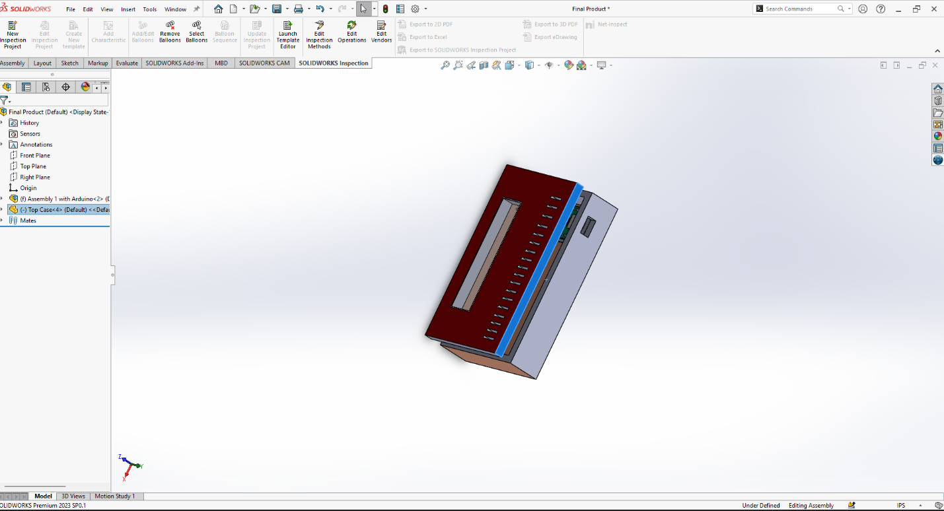

**4. Conclusion**

This SolidWorks design effectively addresses key functional requirements while maintaining a balance between manufacturability, aesthetics, and usability. Challenges such as thermal management, dimensional accuracy, and integration were systematically resolved through careful planning and design iterations. Future improvements could explore alternative materials for enhanced durability or optimized ventilation patterns for better heat dissipation.